Lab 8: Fourier Transform

OBJECTIVES

- Fourier Transform (FT)
- Discrete Fourier transform (DFT)
- Discrete Time Fourier transform (DTFT)

EXERCISES
1) Find and plot the Fourier Transform of the following signals:
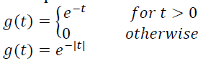
ANSWER
syms t w
% Define the signals
g1 = exp(-t) * heaviside(t); % g(t) = e^(-t) for t > 0
g2 = exp(-abs(t)); % g(t) = e^(-|t|)
% Fourier Transform
G1_f = fourier(g1, t, w);
G2_f = fourier(g2, t, w);
% Display results
disp('Fourier Transform of g(t) = e^(-t) for t > 0');
disp(G1_f);
disp('Fourier Transform of g(t) = e^(-|t|)');
disp(G2_f);
% Plot
f_vals = -10:0.1:10;
G1_vals = subs(G1_f, w, f_vals);
G2_vals = subs(G2_f, w, f_vals);
figure;
subplot(2, 1, 1);
plot(f_vals, abs(G1_vals));
title('Fourier Transform of g(t) = e^{-t} for t > 0');
xlabel('Frequency (f)');
ylabel('|G(f)|');

subplot(2, 1, 2);
plot(f_vals, abs(G2_vals));
title('Fourier Transform of g(t) = e^{-|t|}');
xlabel('Frequency (f)');
ylabel('|G(f)|');

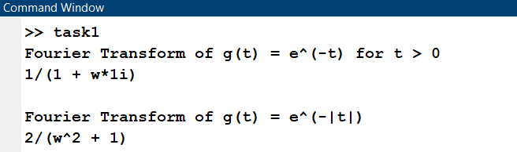
RESULT:

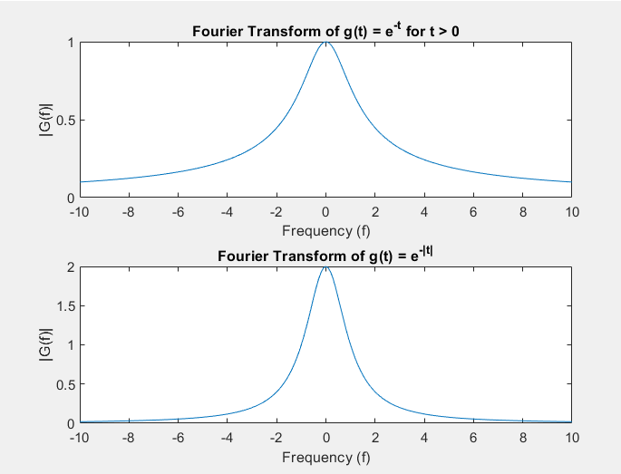

2) Find and plot the Discrete Fourier Transform of the following signals:
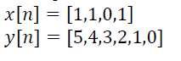
ANSWER
% Define signals
x = [1, 1, 0, 1];
y = [5, 4, 3, 2, 1, 0];

% DFT using FFT
X = fft(x);
Y = fft(y);

% Plot
figure;
subplot(2, 1, 1);
stem(0:length(X)-1, abs(X));
title('DFT of x[n] = [1, 1, 0, 1]');
xlabel('Frequency Index');
ylabel('|X[k]|');

subplot(2, 1, 2);
stem(0:length(Y)-1, abs(Y));
title('DFT of y[n] = [5, 4, 3, 2, 1, 0]');
xlabel('Frequency Index');
ylabel('|Y[k]|');

RESULTS
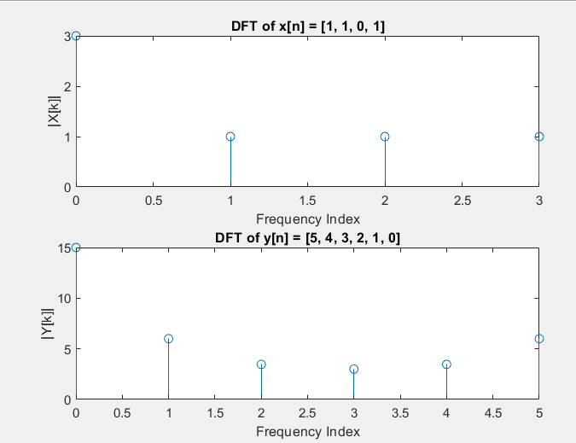

3) Find and plot the Discrete Time Fourier Transform of the following signal:
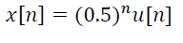
ANSWER
syms n f
x_n = (0.5)^n * heaviside(n);
% DTFT
X_f = symsum(x_n * exp(-1j * 2 * pi * f * n), n, 0, inf);
% Display and plot
f_vals = -0.5:0.01:0.5;
X_f_vals = double(subs(X_f, f, f_vals));
figure;
plot(f_vals, abs(X_f_vals));
title('DTFT of x[n] = (0.5)^n u[n]');
xlabel('Frequency (f)');
ylabel('|X(f)|');
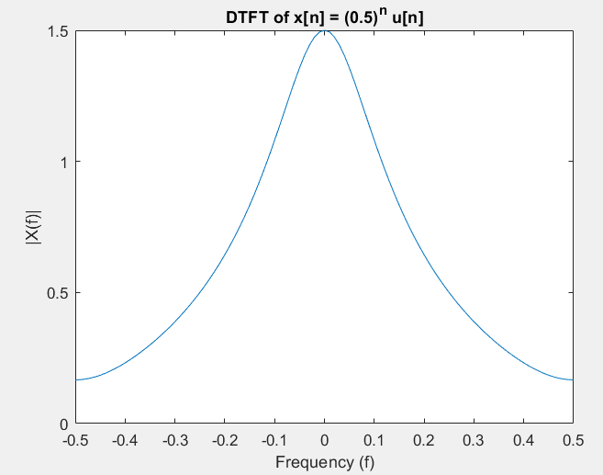
RESULT

4) Write a program to calculate the inverse Fourier transform of a signal and apply it on part 1 to recover the original signals given.
ANSWER
syms t w
% Define the signals
g1 = exp(-t) * heaviside(t); % g(t) = e^(-t) for t > 0
g2 = exp(-abs(t)); % g(t) = e^(-|t|)
g3 = heaviside(t);
% Fourier Transform
G1_f = fourier(g1, t, w);
G2_f = fourier(g2, t, w);
G3 = fourier(g3,t,w);
% Inverse Fourier Transform
f1=ifourier(G1_f,w,t);
f2=ifourier(G2_f,w,t);

% Display results
disp('Inverse Fourier Transform of G1_f');
disp(f1);
disp('Inverse Fourier Transform of G2_f');
disp(f2);
disp(G3);
RESULT:
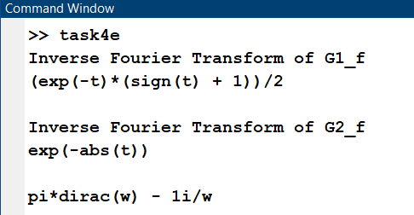

5) Write a program to calculate the inverse discrete Fourier transform of a signal and apply it on part 2 to recover the original signal given.
ANSWER
% Inverse DFT for x[n] and y[n]
x_recovered = ifft(X);
y_recovered = ifft(Y);

disp('Recovered x[n] from IDFT:');
disp(x_recovered);
disp('Recovered y[n] from IDFT:');
disp(y_recovered);

RESULT:
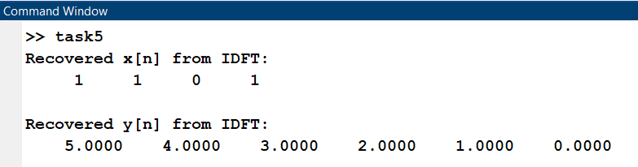

6) Write a program to calculate the inverse discrete time Fourier transform of a signal and apply it on part 3 to recover the original signals given.

ANSWER
N = 256; % Large number of points
k = 0:N-1;
f_vals = k/N - 0.5;

% Compute sampled X(f) for DTFT approximation
X_f_vals = double(subs(X_f, f, f_vals));

% IDFT to recover x[n]
x_recovered = ifft(X_f_vals) * N;

disp('Recovered x[n] from IDTFT approximation:');
disp(real(x_recovered(1:10))); % Display first 10 values

RESULT:

